Set up a Bootstrap web project

- Make sure you have Sublime Text Editor installed and working
Computer labs on campus should already have Sublime installed. If it hasn’t for some reason, please let us know and provide the room number of that computer lab.
Click https://www.sublimetext.com/download to download and install the latest build of Sublime to your own device. (Sublime Text 4 is the current version)
Optionally, you may use another editor (such as Visual Studio Code). However, the tutorial documents have been written according to Sublime Text Editor.
- Download Bootstrap v 5.x from this website and save to your computer.
Access: https://getbootstrap.com/, click “Download”
You need to download the Compiled CSS and JS Version
Note: As Bootstrap is continually being updated, the minor and patch versions may be different from the materials in this unit. The most current version is Bootstrap v5.1.3.
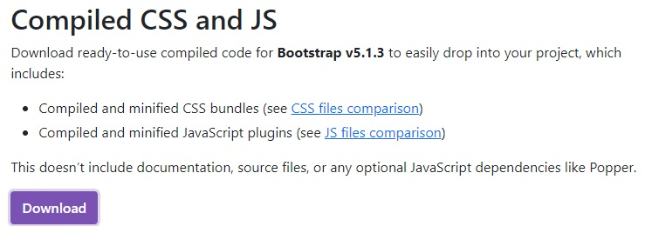
- Start a project by creating a new folder called ‘dev’. Place this folder wherever you see fit on your computer (if you are working on a University computer, place it in your U: drive). We will be using it for the next four weeks.

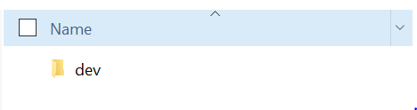

- Create another folder called “Bootstrap” within the “dev” folder
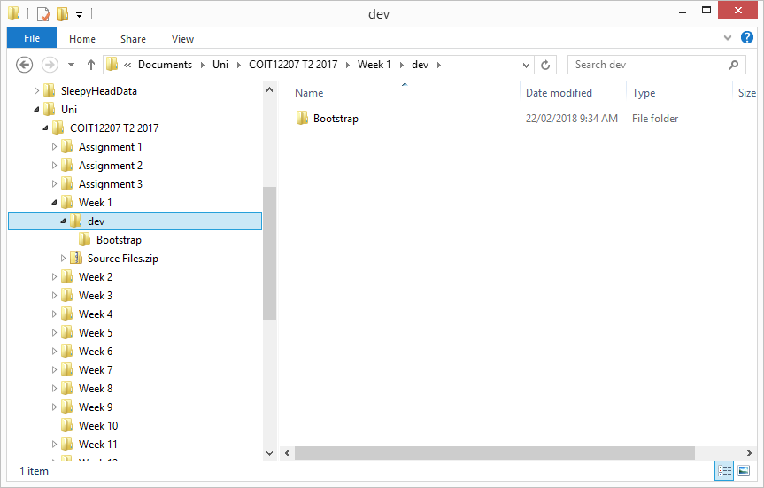
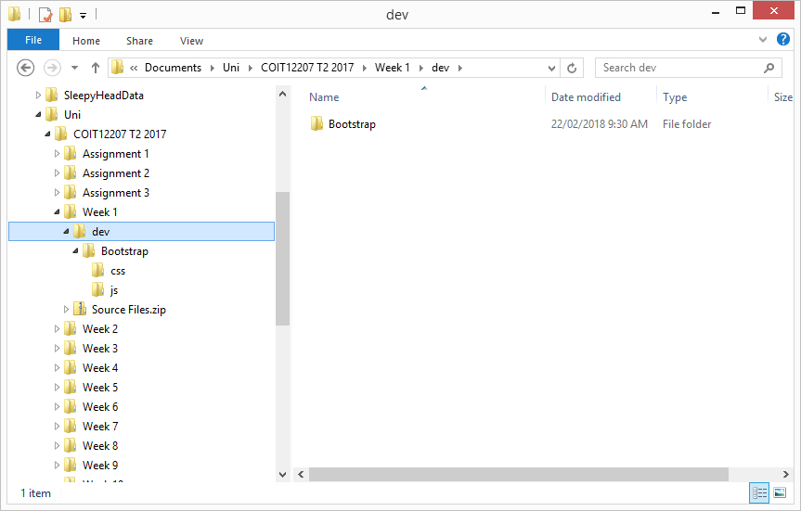
- Unzip the file you just downloaded from getbootstrap.com and copy its “css” and “js” folders directly under your “Bootstrap” folder.

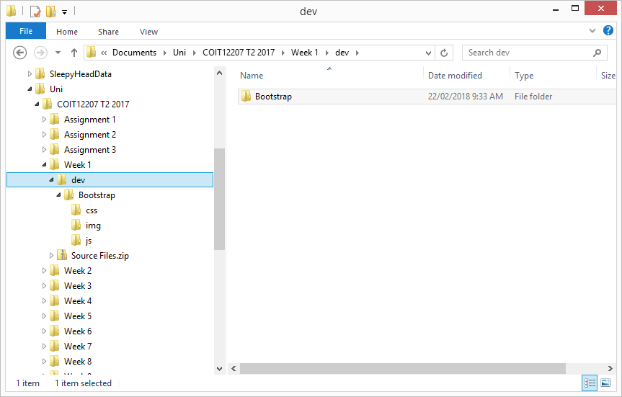
- Within your “Bootstrap” folder, create another folder called “img” for us to store images in the future

- Download jQuery v 3.x.x and save it in your js folder
http://jquery.com/download/
Select the compressed, production jQuery 3.x.x
Note: As jQuery is continually being updated, the minor and patch versions may be different to that shown in any images of this Hands-on Project. The only requirement is for you to have the major version 3.
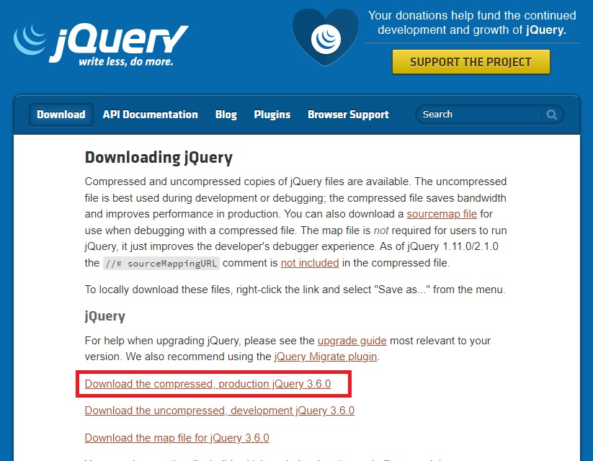
If the download doesn’t start automatically and instead it opens a page with all the code displayed as text (see screenshot below), right click your mouse and select “save as”. Save content of the page to your “js” folder. Keep the filename as it is “jquery-3.6.0.min.js” (your minor and patch version may be different). Later on we are going to reference it using that filename.
(Note: at the time of July 2023, the most recent jQuery version is 3.7.0. You should replace the
<script src=”js/jquery-3.6.0.min.js”></script> by
<script src="js/code.jquery.com_jquery-3.7.0.min.js"></script> )

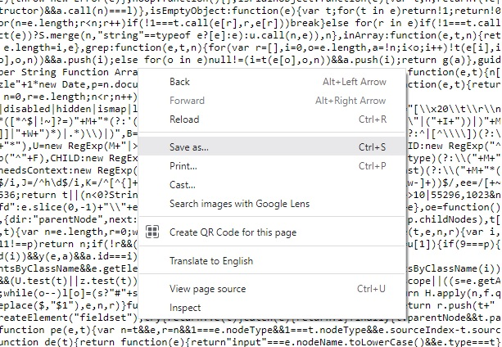

- That completes this hands-on project. Your development environment has been set up.

(Updated on 23 July. 2023)

